# **YAML schema reference**

<https://docs.microsoft.com/en-us/azure/devops/pipelines/yaml-schema?view=azure-devops&tabs=schema%2Cparameter-schema>

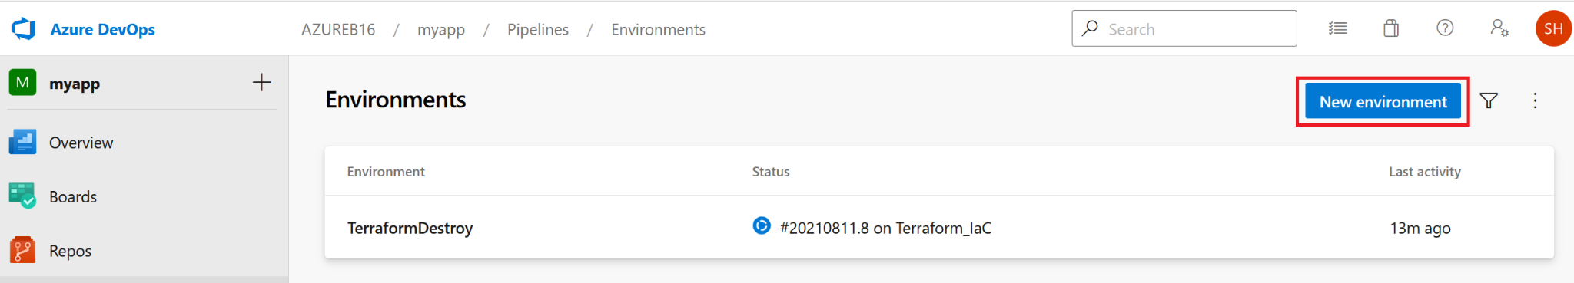

Create multiple agents as shown below and also add capabilities:

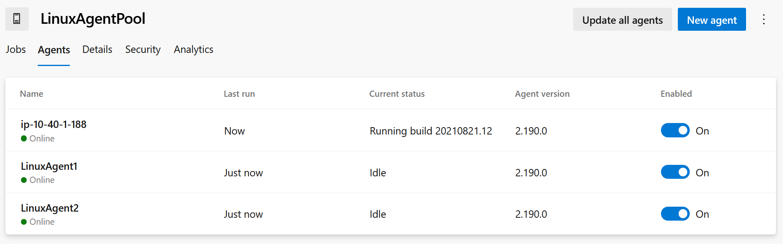

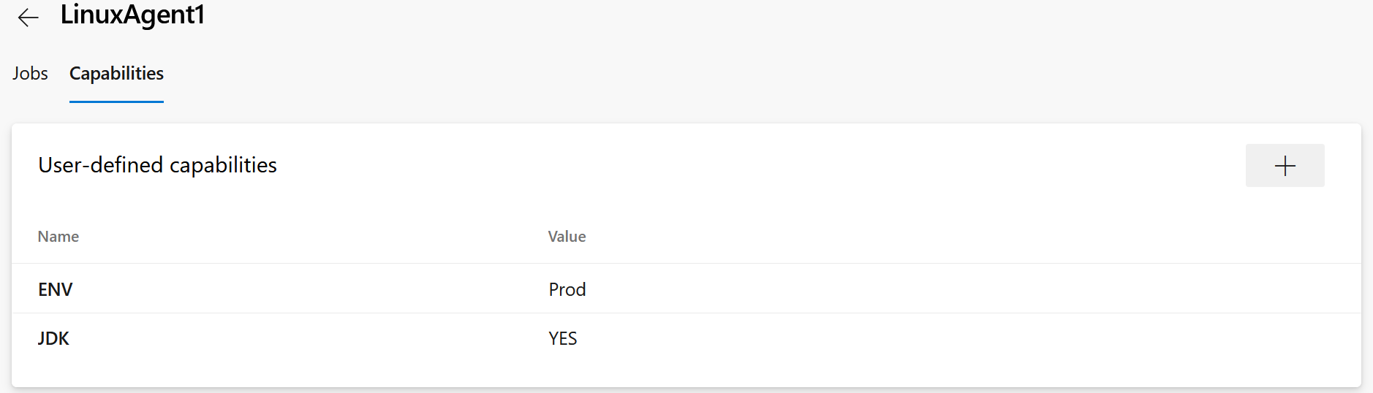

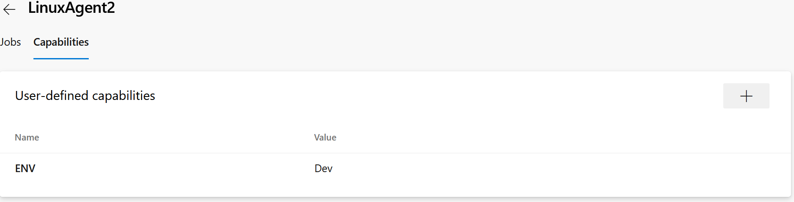

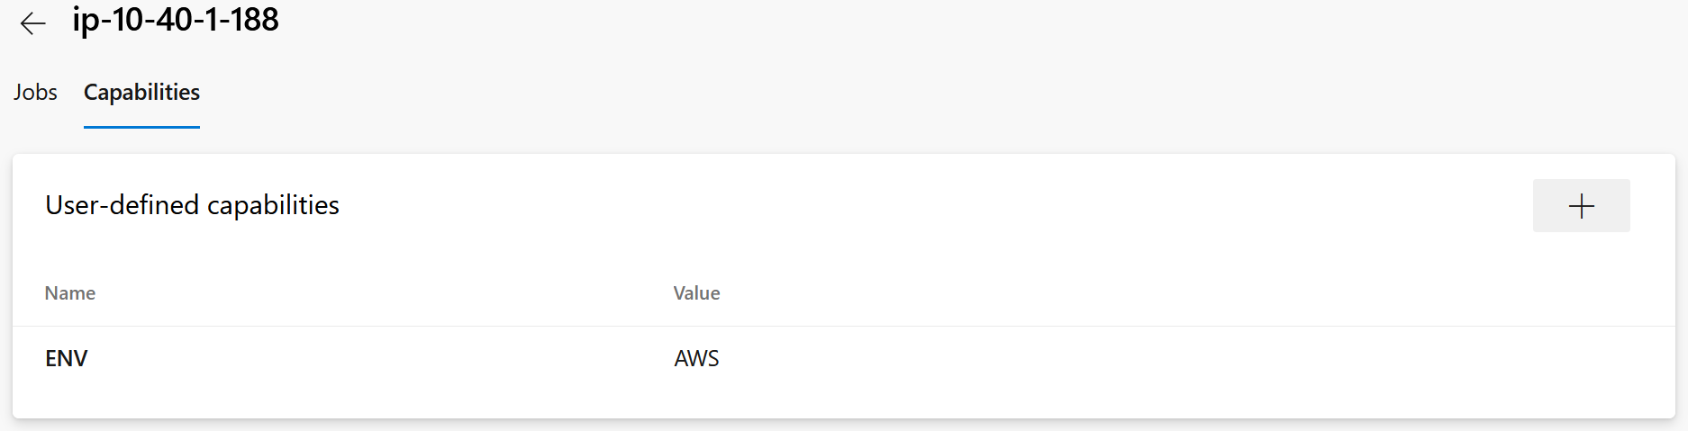

trigger:

- master

stages:

- stage: ProdAgent

jobs:

- job: RunningonProdAgent

timeoutInMinutes: 10

pool:

name: LinuxAgentPool

demands:

- ENV -equals Prod

steps:

- script: echo Running on Prod Agent

- stage: DevAgent

jobs:

- job: RunningonDevAgent

timeoutInMinutes: 10

pool:

name: LinuxAgentPool

demands:

- ENV -equals Dev

steps:

- script: echo Running on Dev Agent

- job: TestOnLinux

timeoutInMinutes: 10

pool:

name: LinuxAgentPool

demands:

- ENV -equals Dev

steps:

- script: echo Testing on Linux!

- stage: AWSAgent

jobs:

- job: RunningonAWSAgent

timeoutInMinutes: 10

pool:

name: LinuxAgentPool

demands:

- ENV -equals AWS

steps:

- script: terraform version && packer version

It is also possible to use a single agent for all stages as shown below.

trigger:

- master

#For using single agent for all stages use below code.

pool:

name: LinuxAgentPool

demands:

- ENV -equals Prod

stages:

- stage: ProdAgent

jobs:

- job: RunningonProdAgent

timeoutInMinutes: 10

steps:

- script: echo Running on Prod Agent

- stage: DevAgent

jobs:

- job: RunningonDevAgent

timeoutInMinutes: 10

steps:

- script: echo Running on Dev Agent

- job: TestOnLinux

timeoutInMinutes: 10

steps:

- script: echo Testing on Linux!

- stage: AWSAgent

jobs:

- job: RunningonAWSAgent

timeoutInMinutes: 10

steps:

- script: terraform version && packer version

Approvals in YAML Pipeline:

<https://samlearnsazure.blog/2020/02/05/approvals-in-environments/>

<https://www.programmingwithwolfgang.com/deployment-approvals-yaml-pipeline/>

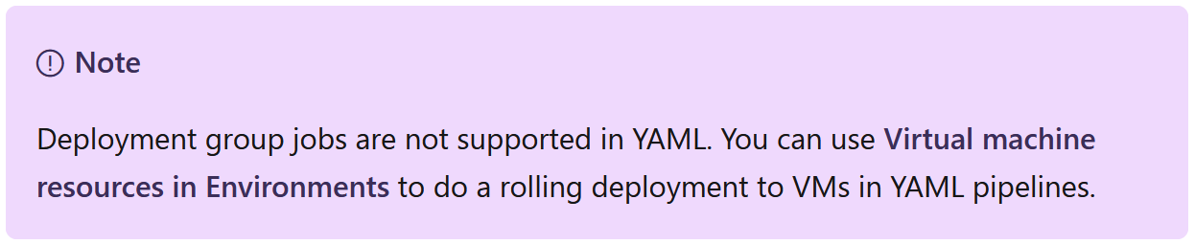

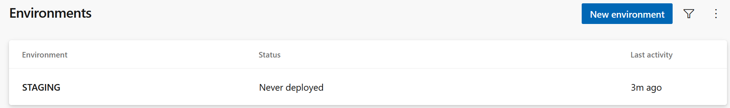

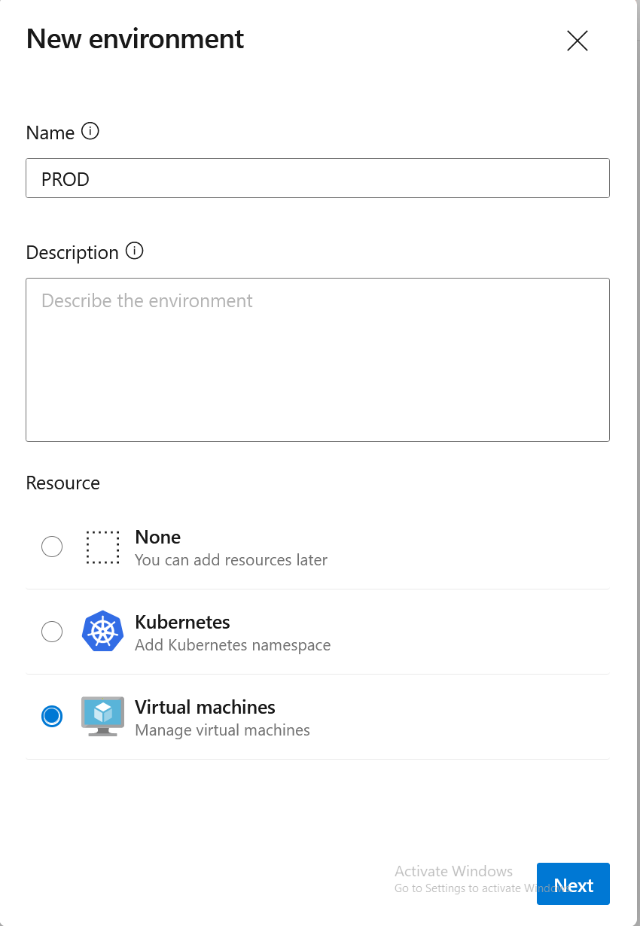

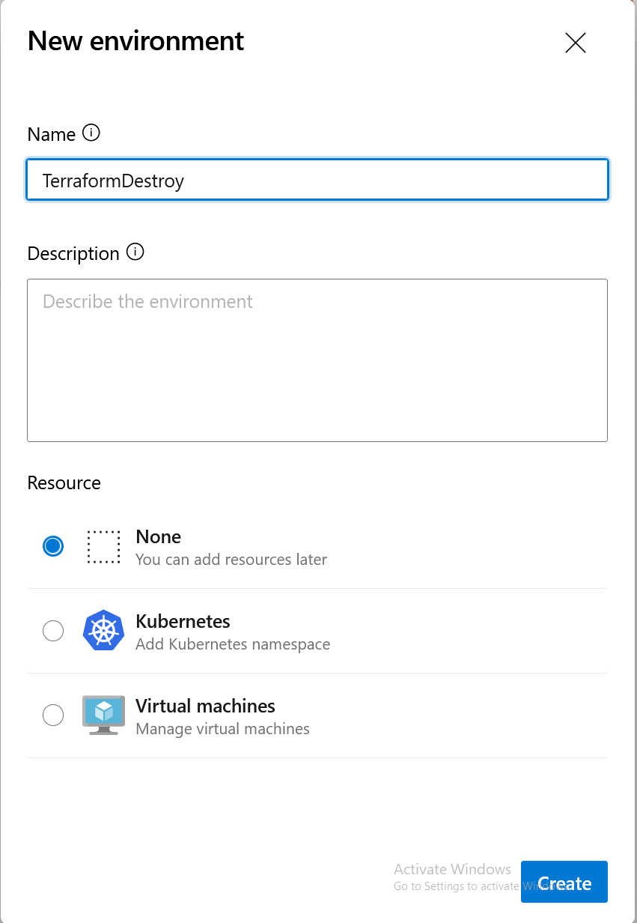

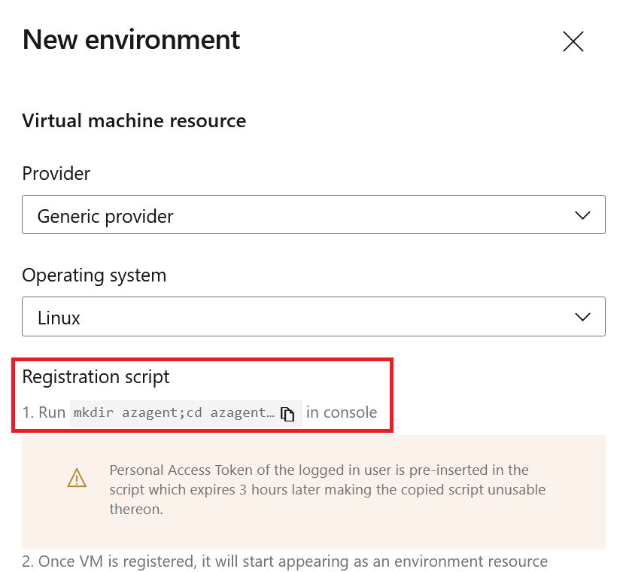

If you already installed Deployment Group agent, better to rename the folder name as azagent2 as shown in the below script.

